

**Department of Computing**

**Te Horo Rorohiko**

**CH3880 Bachelor of Information and Communications Technology**

**BCCE301 Cooperative Education Project**

**Semester 2, 2017**

**Online Quiz project**

**Ara Institute of Canterbury**

**HALFWAY REPORT**

<Daming Zhang>

<99137058>

Table of Contents

1 Introduction 2

2 Executive Summary 2

3 Background 4

4 Expected outcomes 4

4.1 Industry Outcomes 4

4.2 Academic Outcomes 5

4.3 Personal Outcomes 5

4.4 Comparison of Initial and Actual Outcomes 5

5 Progress Made 7

5.1 Overview of objectives 7

5.2 Milestones achieved 8

5.3 Problems encountered 10

6 Course Management 12

7 Review of previous courses 13

7.1 PR282 BEST JAVA Practice 13

7.2 BCIT388 Mobile Technology 13

7.3 PR203 Database Management Systems 14

7.4 CE301 Cooperative Education Project 14

7.5 PR280 Software Engineering 2 16

7.6 IS301 Management of ICT 17

8 Risk Management 17

9 Quality Assurance 20

10 Methodologies 22

11 Main Areas of Learning 23

12 Evidence for Assessment Achievements 24

13 Appendices 29

14 References 30

# Introduction

This report gives the summary of what I have done in the project. The Online quiz final report is about 30 pages. It covers these aspects:

* the explanation of the project and its background
* how it was planned and implemented
* the achievements of the project
* how the project was managed using Extreme Programming plan
* evaluation of QA programs and risk management programs
* conclude this report with the methodology essay summary, agile for software management.

# Executive Summary

Anne Wignall is a retired teacher of science and chemistry. She is also a textbook author. In recent few years, Anne has devoted herself to create a number of computer activities to help student to study on Moodle. Anne wishes to perfect Diagram quiz and Hangman exercise.

My mission is to fix the quizzes, translate them from Flash/Actionscript into html5/ES6 and work on Moodle 3. The project also needs to be supported by smart phone and tablet (Android&IOS).

The tasks are:

* Diagram:
  + Dragging the correct keyword answer label into the appropriate box, the positions of the boxes display random coordinates each time.
  + Input the right answer into the appropriate boxes the position of the boxes display random coordinates each time.
  + Dragging the correct image answer label into the appropriate box, the positions of the boxes displayed base on the XML file.
  + All the types of Diagram needs to display score base on the how well users answer the quiz.
* Hangman: Filling the blanks of missing words of a definition and show the process of getting the all of the words right. Record the letters that are not in the answer. It also needs to record the score. The answers and question are created base on the XML file.

# Overview of future objectives

At the halfway of the project, some new features were added and some activities were cancelled, the outcomes have been re-negotiated, the details as follow:

Before the halfway, the original plan for my client is to create 4 activities:

Diagram with two types, input type and drag type;

Hangman with animation;

Chemical diagram;

Better solution of multiple circuit diagram answers;

During the development period by the halfway, the actual outcomes are

Diagram:

1. For drag type, the answer boxes and the point aiming at the picture need to be generated by random position each time users refresh the web page.
2. For input type, the label boxes’ background change colour by times that users get wrong answer input and if users get 4 times wrong answer. The correct answer will automatically display in the box and user can not change it.
3. The score system make user to get different points base on the times they get right. First time users get correct gets 100% for the question, second time get 75%, third time gets 25% and users get no points by the fourth time.
4. Responsive design of the layout.

By the time developing Diagram project, I made coordinate generator tool for creating quiz more easily for my client. That is out of the original plan. In the future, The priority of the Diagram activity final outcome is completely finishing development and testing the “input” type and “drag” type on Moodle environment. In addition, there is an option feature which is dragging images instead of dragging label. If it will be more time at the end of the project, My client and I would be happy if I get the option feature done.

Hangman: The Hangman just has been started. My client’s priority of the final outcome of the project is implementing the functions and testing on the Moodel environment.

The basic features are:

1. Guessing sentences base on the tips.
2. Setting an appropriate limited time of chance.
3. A recording score system to calculate score base on how many chances users are left.
4. Responsive design of the layout.

In the future, I am going to finish all the requirement I mentioned before and doing extra miles to get my client satisfied.

Such as:

1. To show the right answer in different colour to user.
2. Making noise when users putting wrong letters.
3. Getting random questions from the xml file instead of getting in an constant order questions.
4. To show and record the letters that users have typed incorrect.

As the project proceeding, the Chemical diagram and Better solution of multiple circuit diagram answers projects are cancelled. Because the priority is to get Diagram and Hangman perfect done and some more features are going to be added.

# Background

Anne Wignall is a retired teacher of science and chemistry. She is also a textbook author. In recent few years, Anne has devoted herself to create a number of computer activities to help student to study on Moodle. Anne wishes to perfect Diagram quiz and Hangman exercise.

Anne uses a quiz tool called Hot Potatoes to create quizzes in HTML and JavaScript. The plugin Hot Potatoes, allows quizzes to be run on Moodle. The version of Moodle on Anne’s PC is Moodle2. The schools she works with are using Moodle 3 now, which is part of the reason that need to upgrade the files to the demanding environment of Moodle3. The currently issues are:

Diagram:

1. It can not to be set as an activity on the Moodle now. It cannot get mark from Moodle.
2. Each time that the diagram generated has different coordinate of answer boxes, The boxes always keep in the same position in the diagram at the moment, so when users do the diagram quiz they may just remember the order of the answer not really know the answer match what part in the picture.

Hangman:

1. It has not to be set as an activity on the Moodle now. It cannot get mark from Moodle.
2. Anne wants students to fill in a whole sentence or a short paragraph by guessing letters until they can determine the missing words. Also the Hangman needs a sort of count number to calculate how many times users can get wrong guessing letters. Some sort of gamification such as an animation that includes bombs, explosions or crashes when letters are wrong is desirable but not essential.

There is a table of “initial and final outcomes”, see page 5.

# Expected outcomes

## Industry Outcomes

The project has the following outcomes.

* Features that required
* The testing results
* The defect tracking
* API Documentation of the online quiz resources for maintenance

## Academic Outcomes

* Project proposal
* Academic / Industry supervisor assessments
* Methodology essay
* Halfway report including
  + Risk management for project
  + Quality assurance for project
  + Review of 200 and 300 level courses

## Personal Outcomes

I have learnt the following skills and knowledge that I gained from doing the project

* Deeper understanding of JavaScript
* GitHub for version control
* Moodle as the programs work on Moodle
* jQuery to support multi-platform
* Extreme programming for project management

## Comparison of Initial and Actual Outcomes

A table to illustrate the outcomes at different stages:

|  |  |  |  |
| --- | --- | --- | --- |
| Activity name | At beginning | At ½ way | At end |
| Diagram  (drag/input) | Was required at beginning.  1. Drawing a line to match box and point. Drag the appropriate answer card to the box.  2. Generate the boxes in certain order.  3. Only has drag type.  4. The first demo used the new xml configure file.  5. Responsive design. | 1. Replace drawing line to match box to creating colorful index to match box and point. (The best solution of three options)  2. Generate boxes in a random position with the same color of point’s index.  3. An new “input” type of Diagram was developed, users have 4 chances to get a correct answer by inputting right letters, also change the background color to indicate the different stage where user at.  5. Fit the code to use the original xml configure file.  6. Set a passing score.  7. Implement the responsive design.  8. Creating an API guide documents for subsequent developer maintenance. |  |
| Coordinate Tool | Was not required | That is an extra mile work in order to help client easy to create quiz. It was finished before halfway. The tool can record the coordinates of a given point in a loaded picture. It also generate xml code automatically for client. |  |
| Diagram(image) | Was not required | Was required in the halfway |  |
| Hangman | Was required at beginning.  The basic function of completing the missing word. An animation to show the process where user at. | Requirement was changed:  1. The animation was canceled.  2. Duplicated letter does not count for an extra input count.  3. Record the letters that users have put.  4. Record the wrong letter that users have put.  5. Get random questions from the questions list.  The Hangman project started in the beginning of halfway. | 1. Fix duplicated inputting same letter bug.  2. A more comfortable and colorful layout.  3. Set a label to show users’ chance.  4. Record the letters that users have put exist in the question.  5. Record the letters that users have put no exist in the question.  6. Put a cross and tick picture to indicate the question if is correct.  7. Show the correct answer with highlight letters which users can not guess out.  8. Get a certain number of a list of questions from xml file and questions are picked randomly out of all the question. |
| Chemical quiz |  | Canceled in the halfway |  |
| Multiple circuit answers solution |  | Canceled in the halfway |  |

# Progress Made

## Overview of objectives

The programs have to work in Moodle 3, which has added security levels; they need to work with Firefox, Chrome, Safari and Microsoft Edge. The project is not bothering with Internet Explorer. They need to work on mobile devices with touch screens, both iOS and Android, and desktops, and laptops. Users are primarily students in the third world.

1. The project is aiming to fix all agreed problems to the existing resources. Each activity has different issues.

2. After fixing them, it also needs to implement new features (animations) that Anne requires to add to these activities according to the requirements.

3. It needs to make the user more positive and motivating to use the quiz for studying on Moodle.

Details see Appendix A

|  |  |
| --- | --- |
| Quiz name | Achievements |
| Diagram  (drag/input) | All objectives were achieved.   * Identify and fix all bugs * Modernise * Add new features and a tool * Improve maintainability with API document |
| Diagram(image) | * This was not in the original quiz list. Just start at the moment. |
| Hangman | All objectives were achieved.   * Identify and fix all bugs * Modernise * Improve usability * Improve maintainability with API document |

## Milestones achieved

An achievement list and a burndown chart to show where the milestones were achieved.

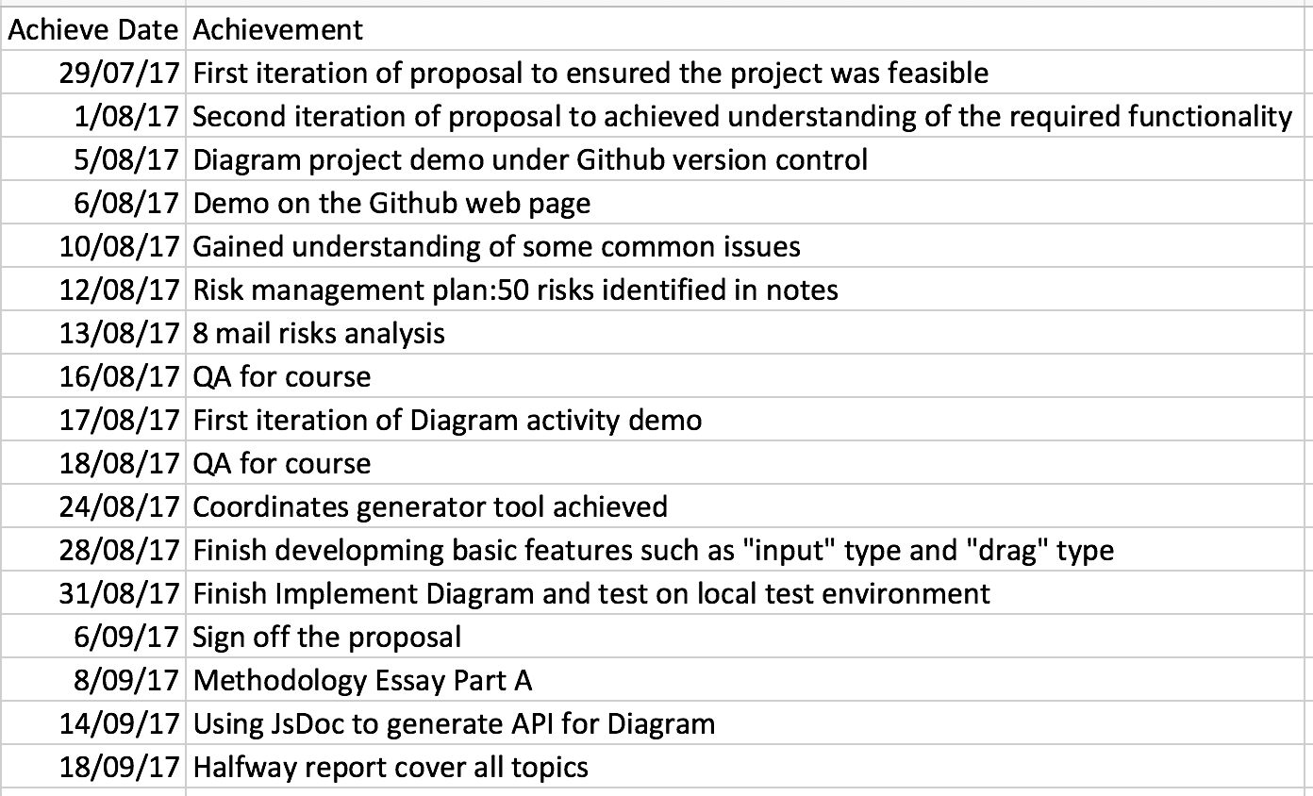

**Research of Dirgram and related issues**

* Ensured the project was feasible.
* Achieved understanding of the required functionality.
* Diagram project demo under Github version control and a demo on the Github web page.
* Gained understanding of some common issues.

**Risk Management Plan**

* 50 risks identified in notes.
* 8 main risks’ details documented for top 5 risks. Including:

impact, possibility and contingency plans

**Quality Assurance Plan**

* QA for course: Task list created to ensure the project meets or exceeds the required quality.
* QA for industry: Metrics defined for determining the success of the final product.

**Diagram project maintenance**

* Get knowledge of using JsDoc3 to generate API documents automatically.
* Tackled some major issues early.
* Used to refine project requirements.

**Diagram project functional**

* Diagram project created. Including two types of quiz: drag and input.
* Tested functionality on Chrome, Firefox, Safari browsers.
* Tested responsive design on Iphone6 and Android

**Diagram coordinate generator tool**

* The coordinate generator tool created.
* Tested functionality on Chrome, Firefox, Safari browsers.

**Hangman project**

* Gain experience of Javascript event binding.
* The basic functions such as guessing the missing letters,

**Management of CE301 Course**

* Implemented basic function, on progress
* Proposal: After meeting with client Anne, I took two days to get a proposal draft, after that I show it to my industry supervisor, academic supervisor and client, got feedback from them. Then modified it. I got it sign off by client on 6th Sep.
* Daily Plan: I meet with my industry supervisor Mike on Monday every week to show him my plan of the whole week, write detail work for each hour. I study about 6 hours on this course from Monday to Friday.
* Weekly report: I get feedback from the weekly meeting with Phillip and Mike, they give me suggestions and track my process every time to lead the course work can be finish in an appropriate pattern.
* Methodology Essay: My methodology essay topic is “Agile Project Management” I have written the part A of my methodology essay base on what I have meet with my client during the development period for the first 6 weeks.
* Halfway report: Before I finish the Halfway report, I prepare a list of deliverable and document for proving what I have done during halfway time.

## Problems encountered

Software management

* Changed requirements: It is quite normal that every time after meeting with client that the requirement changed. After I estimated the time consuming, I changed my original plan.

Sometimes adding an simple button was not as easy as it looks like, because the code is structural, I need to modify with several files and sometime I need to modify the logic of code, the CSS of html. Some potential problems or bugs may come out. Even I am not focusing testing at the moment but I still need to keep every function runs well, so after adding new code, I always test all the exist functions to ensure that the changes would not affect the original code. Another problem is some previous work may be useless or waste after getting new requirement.

* Features added: Same as changed requirement, sometimes client may propose some new features. The problem is quite like I mentioned with changed requirement. Adding new features needs to modify my plan and may change the logic of original work, also I need to modify everything that related to the code, such as API document. In my case, I made a coordinate generator tool for my client which is out of the original plan. And after that, there were some new features that need to add for the coordinate tool. I spent a lot time to research and create that tool, so I worked extra time in that week because I really want get the project perfect and done.

In order to manage the project and nicely communicate to client and get the client priority, I used agile extreme programming planning to better manage the project.

* API for maintenance: My laptop is a MacBook, when I first to get an API generator tool, I have tried to download a lot version of JS generator tool.

Finally, I used JsDoc3 with NPM support to solve the problem.

Personal factor

* My personal English is not very good, sometimes I worked a lot and I think I worked very effective, but my client may not know. A lot effort is behind the code. I need to show her my work and let her be satisfied. I also need to show a lot evidence to my supervisor to get the ratification. Because I am going to find a job in New Zealand, it is quite important for me to get a high grade.
* Research and study while developing HTML5 animation. I have not enough knowledge of HTML5 animation, so I spent several hours for watching the tutorial from the Internet. And did some practise for better understanding the knowledge and preparing the project.
* HTML5 drawing pictures with canvas skill are not responsive, using DOM to draw can be responsive but it takes a lot computer resources.
* The resources of using JavaScript are almost written in ES5 version from the Internet. It needs to take more time for researching.
* With doing the project, I also need to study DataBase course and to finish the assignment in the last two weeks before half-way, I only reduced 4 hours work for project and take more than 8 hours on Database in that week. And I put extra 4hours in the following week for the project. So both project and DataBase course went smoothly, I felt good where I were at that time.

# Course Management

**Time Management**

* MyHours track time log
* Plan the work for next week in detail

**CE301 Cooperative Education Project class to accompany project**

* Track the process of the project and guide me a professional way to accomplish the project.

**Compromises in other aspects of life**

* Prioritizing:

Online Quiz Project>CE301>PR203 >Exercise>Relaxation/Sanity> Social Life

**Daily plan, weekly reports and progress meetings**

* Do daily plans for next week on every Monday after meeting client.
* Talk about where I’m at of the project. Major issues and successes with Dr. Mike and Dr. Luofeng.
* Check and discuss academic work with Phillip at least once a week

**Effectiveness**

It is quite helpful and effective that records time consuming. Make plan before the week in details for every hour. That leads me to have more clearly goal. It also push me to work more concentrate.

I meet my supervisors three times once a week, they help me to give me idea and guide me to solve the problem I encountered. They also check my work from previous week. It ensures that the project goes smoothly in every stage.

**Reflection**

It reduce stress when I am working in a week, because everything was sorted and planned. It gives me a big view of whole week and my supervisors helps me to manage the project better, let me be able to confident to finish the project.

# Review of previous courses

## BCPR282 Best Programming Practices (Java)

* **Programming best practices**Best practices of separation of concerns, SOLID principles were taught in the class. I used the practices in the project.
* **MVC in ES6 using custom events**In the project, I used JavaScript program into MVC model. While I applied it into the project, it made the project more maintainable and structural.

**Recommendations**

This is a course that makes me easy to get into the structural coding, separate the code into model, view, and controller standard. It is quite useful and easier to maintain in the future. On the other hand, the final assignment is about an Android App, it may a little bit harder for a learner to make the App.

## BCIT388 Mobile Technology

This course teaches technique knowledge of Mobile, such as the importance of complexity of password, the Wi-Fi and Li-Fi in people’s lives and Gamification. In the first several weeks we practise to design several small Android game by Google MIT App Inventor. It is quite easy and fun to quickly get start to develop Android App.

**Recommendations**

Gamification is a very important game principles that it encourages and improves people engagement. It can almost embed into everything to get a positive effects on individual’s ability to understand a certain area of study. I was required to put an animation game in my project, although it was cancelled, I still believe it is going to be attractive after adding that feature.

## BCPR203 Database Management Systems

This course is aiming to understand the significance of Database Management Systems. To gain the knowledge and the technical skills of how to design, implement and manage a relational database in business. It also teaches students how to write SQL statement. In the class, students practise design database by real business case.

**Recommendations**

I chose this course because database knowledge are always combine with website project’s back-end. After I learnt this course I got a whole view of full-stack developer. It wide my knowledge and it is going to be very useful in the future. But in my current project there is not too much point that related to this course.

## BCCE301 Cooperative Education Project

This course gives the opportunity to students to communicate with technology industry. Make students learn different areas of technical computing skills and experience in an industry environment. Explain the problems that encounter in the project, the agile software management and Describe the quality assurance and risk management in the project.

In addition, students need to evaluate the 200 and 300 level (Level 6 & 7) courses that are helpful for the project, and the reason that they better support the project.

**Recommendations**

This course more depends on self-teaching, supervisors give students direction and help us to solve problem no matter academic or industry.

What's more, the course is helping students to track the process of project and ensure to accomplish the project.

However, the most time is on implementing the project get client satisfaction. It will meet many areas of problems, to solve those problems, it almost rely on students themselves and need to get the supports from supervisors immediately. It saves time than thinking all by oneself.

## PR280 Software Engineering 2

This course is the most relevant in all the level 200 & 300 courses that I took. It teaches JavaScript programming and frameworks and the practise and assignments with Personal Software Process (PSP) that is an Agile development process. This course was really like the process what the project like. The agile development process is quite like what happens in the reality in the industry, this course helps me a lot.

* **JSHint**A code checking and analysing tool that helps developers to find out errors and potential problems in JavaScript code. I used it combine with standardJS in the project to check my JavaScript code..
* **Toggl**A tool to record time. I used this tool in course, but I am using Myhours in the project for same purpose.
* **JavaScript ES6**  
  The latest version of JavaScript. I used this as main programming language in this project. A good thing about the course was that it involves pretty much coding, so I got used to writing JavaScript quickly. Taking this course at the same time helped a lot because I could ask programming questions in class.
* **Jasmine**This is a JavaScript testing framework. Write testing code follow the Jasmine syntax, then automatically check the functionality of each function in the code.

**Recommendations**

The course was the most useful for me. I have learned about Jasmine framework test automation. Also taught to use Angular1 in ES6 to develop project. Angular is a quite popular development framework in the industry at the moment, I fell happy to learn it, however, Angular in ES6 version does not have enough resources in the Internet, it almost write in ES5 version.

## BCIS301 Management of ICT

This course is looking at the bigger view in ICT. It teaches how to use frameworks to evaluate, analyse, and convincing solutions to studying IT governance. It also teaches students to use COBIT framework for risk management.

* **Gathering information**In the course, students got a task to practice to participate in an interviewing and gathering information with using the frameworks to gather and separate the information in order to analysis and evaluate the better choice of solutions.
* **Risk identification and evaluation**Students also learned a Risk IT framework, which is called COBIT. It explains risk into 4 main areas and I use this risk management knowledge in case study, created criteria of evaluation and the hierarchy of best option.

**Recommendations**

I used the skills from the course to evaluate potential options or solutions for my project. The course help me to give me a direction of thinking where risk from. But in fact, what we learn from the course is more about theory, we may lack of experience in the real project.

# Risk Management

Risks in the software developing can not be avoid, many reason can slow down the project or even make the project fail. There are three parts of risk needs to consider.

1. Project Risk – some factors could cause a project to fail;

1.1 Financial - the investment of the project is not enough;

1.2 Strategic – the requirement may change or need to add some new feature;

1.3 Technical – the key technology of the project may not get enough support in the future;

1. Production System Risk
   1. The production support team members may have not enough experience and skills sometimes.
2. Personal Risk

3.1 The degree or the knowledge of skill may not enough to support the project.

3.2 The impact on developers health and the emotional will effect the project schedule.

| **Risk name** | **Impact** | **Possibility** | **Exposure** | | **Mitigation** | **Contingency** |
| --- | --- | --- | --- | --- | --- | --- |
| **Member not familiar with the technology** | 80% | 80% | 64% | Schedule time for learning and researching | | To get support and helps from Academic and Industry Supervisor |
| **Requirements change or be added** | 60% | 70% | 42% | Check with the client’s priority. Then modify the plan of project | | Change project plan and take changes into the next weekly plan |
| **Testing environment not available** | 80% | 20% | 16% | Check available environment | | Build environment |
| **Too many bugs that not all can be fixed** | 80% | 20% | 16% | N/A | | Change project scope to fix only those of high priority |
| **Member sick** | 80% | 10% | 8% | Do not work day and night, having rest is important | | Have enough rest every day. |
| **Client is not available** | 30% | 20% | 6% | Get the client’s schedule beforehand | | Make plan to do things that I can do without the client |
| **Data lost** | 90% | 5% | 4.5% | Using GitHub and One Drive to manage the version control | | Download from repository  Or One Drive |
| **Budget might be needed** | 50% | 1% | 0.5% | Check if I can use budget and how much | | Select methods that do not need money |

**Effectiveness**

In order to finish the project, it is always good that try to predict the risks before they happen. After analysing the risks it reduce pressure when the risks come out. Because I have already give the solution. And the best way to solve the risk is preventing it not to happen. Such as I use Github for my project version control, so it significant decrease the rate that the Data lost risk happen.

**Reflection**

In the project, the risks I mentioned in the table are changed requirements and features added. I made a tool for my client to create quiz.

Because It is a free-pay project, so there is no budget risks. I put all the code and documents on the Github to save all the materials to prevent data losing.

Another risk is I am lack of using HTML5 canvas to make animation, but this requirement was cancelled.

The project is developed just only by me, I have never gotten sick and although my client had a surgery but she recovered very quick. We have not missed our weekly meeting.

# Quality Assurance

Quality Assurance is short for QA, which means the approaches of checking if a project meets the client’s requirements.

1. Readability by maintainer: In order to making easier for maintainer, write readable comments and modularity code help maintainer understand the system quickly.
   1. Comments: It includes function header comments and line comments. Describe what happens for the code.
   2. Modularity: Make the code structural and clear, can be easy to add up new function or reuse the code for maintainers.
2. Separate js file: Separate the js file into different file base on the class and design pattern
3. Classes: Create classes base on the
4. XML structure: The XML should be structural, it should not write every tag in one line. It needs to

use indentation for each child tag.

1. Functionality: The project should work as required, which means the project works. There are three main users that will use the project and care about the functionality.
   1. Client
   2. 3rd World students on mobile devices
   3. Teachers- create new quizzes by modify xml file

**List of deliverables**

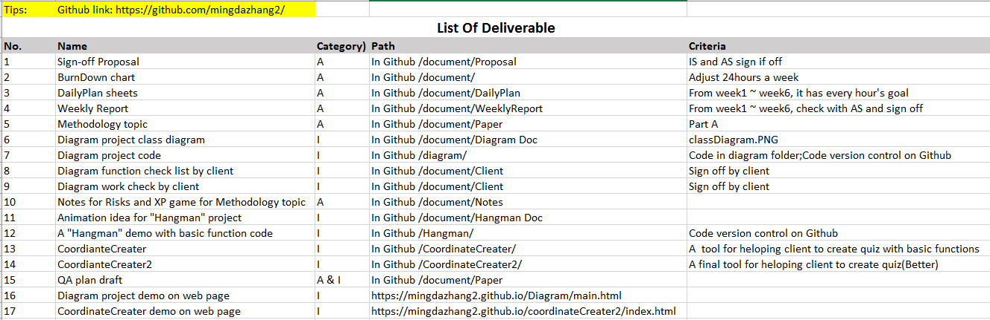

**Effectiveness**

**Reflection**

# Methodologies

For this part, my methodology essay topic is “Agile software management”. Agile management of IT project is widely used for software development. Extreme Programing as a common agile method, it was first used in the mid 1990’s. It is successful method because it leads customer to fell satisfied. It is not easy to deliver everything that as developers planed forego on some date very far in the future. With using this method, the process delivers the achievement as you plan it. Extreme Programming makes developers to respond confidently to changing requirements or adapting to client feedback.

The XP planning game emphasizes teamwork. Clients, managers, and developers are all equal important role in the collaborative team. It implements a simple and effective environment that encourages and enables developing teams to become highly productive. During the programming period, I met my client Anne one a week. Every time after meeting the requirements changed or were added. It is quite normal happened in the industry. So a good strategy of effectively and clearly communication skill to negotiate with client is very important for managing the project.

# Main Areas of Learning

I have learnt the following skills and knowledge that I gained from doing the project

* Deeper understanding of JavaScript
* GitHub for version control
* Moodle as the programs work on Moodle
* jQuery to support multi-platform
* Extreme programming for project management

# Evidence for Assessment Achievements

Diagram online quiz Screen shots - storyboard

Input type:

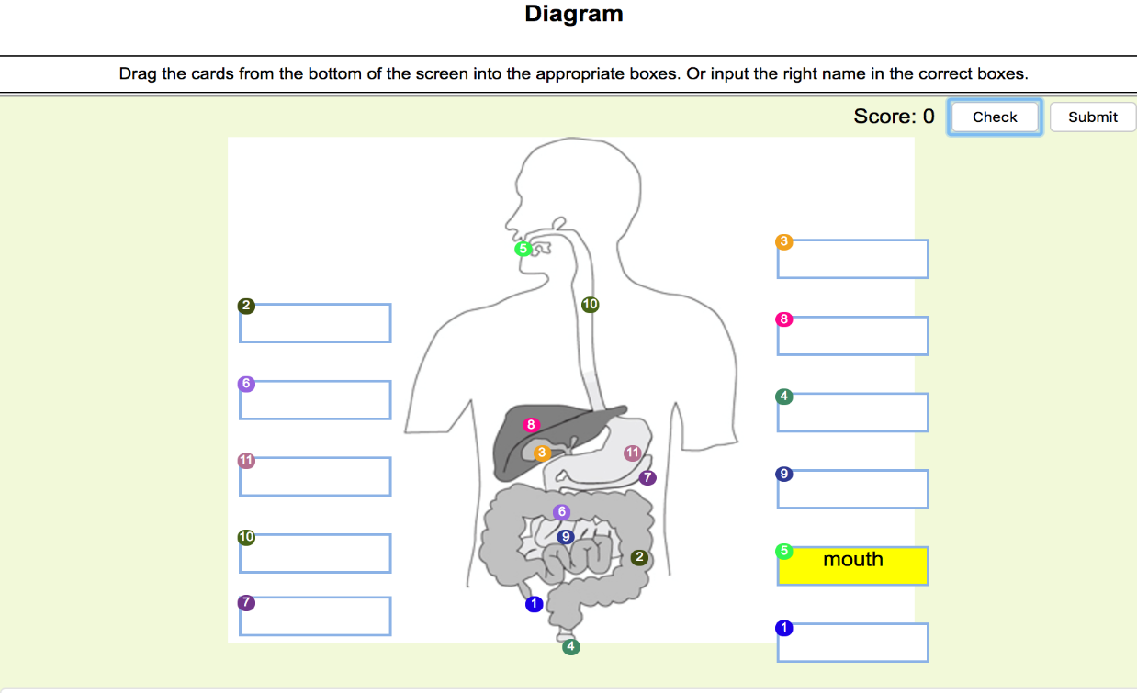

Drag type:

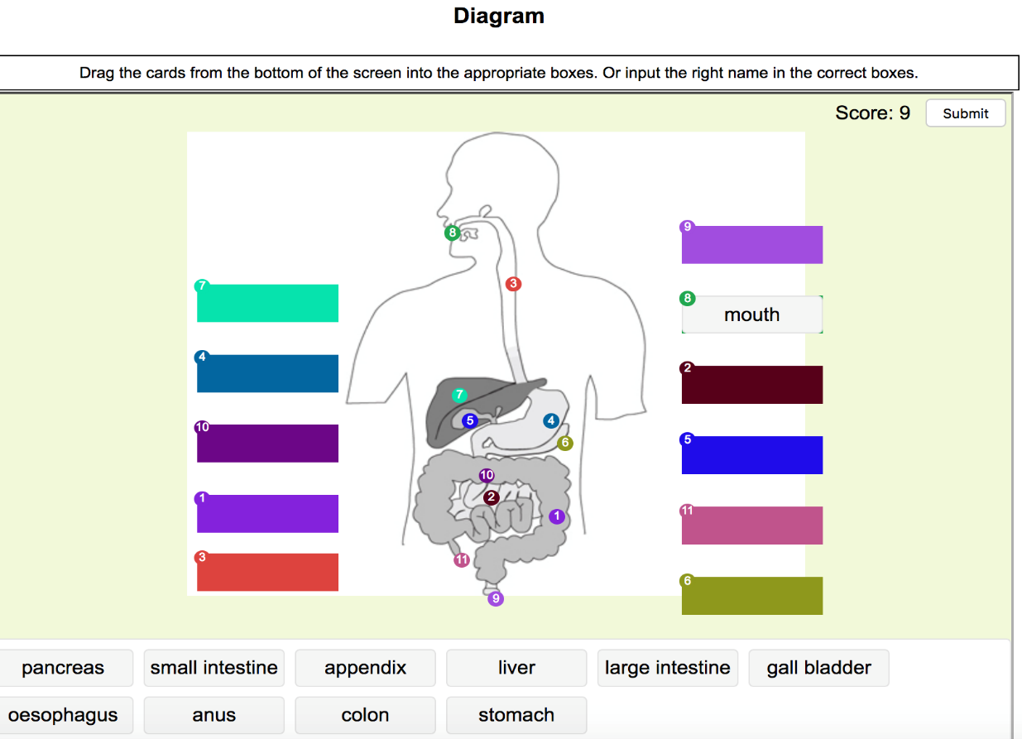

Code snippets: Diagram quiz.js code

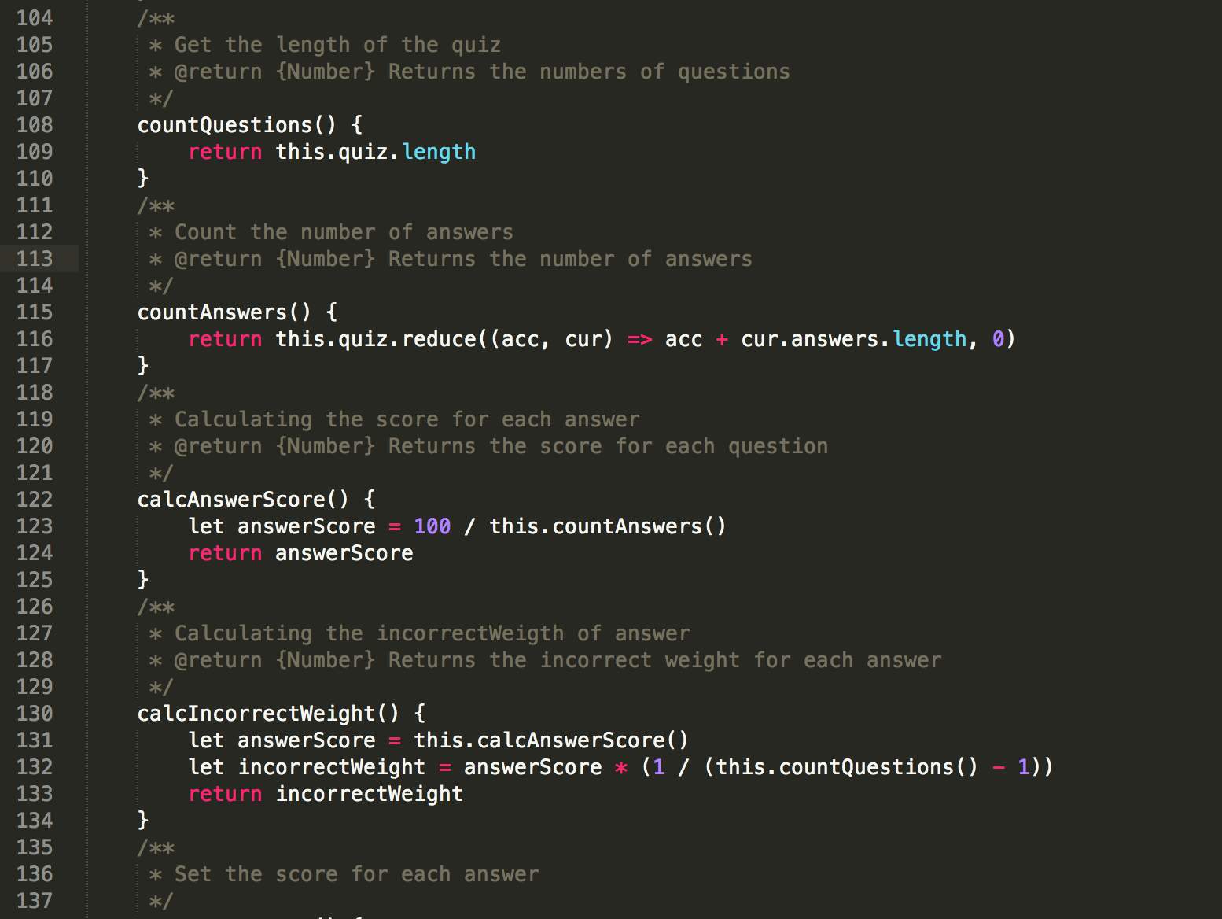

Github code version control and document management screen shot:

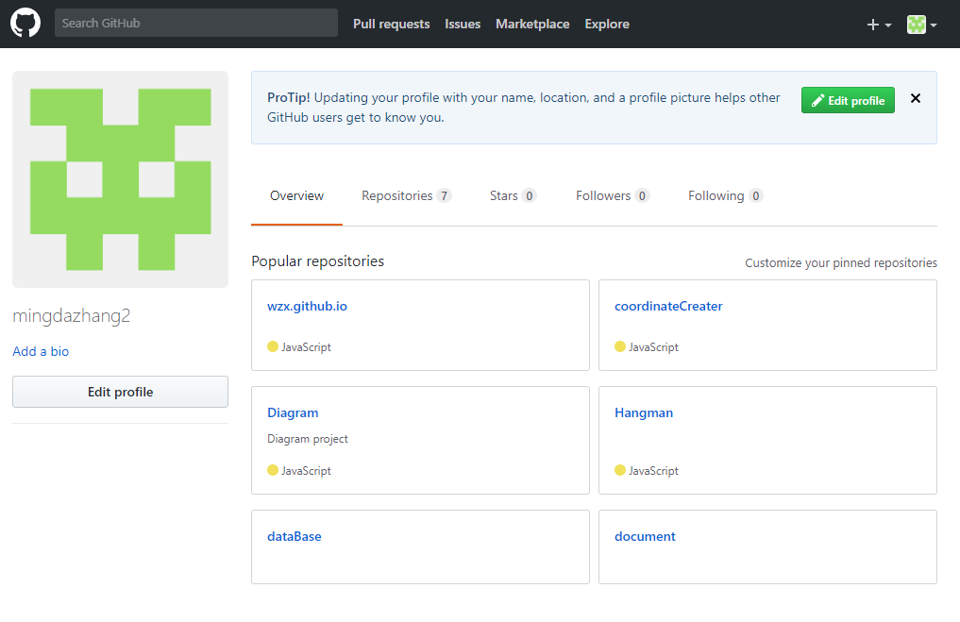

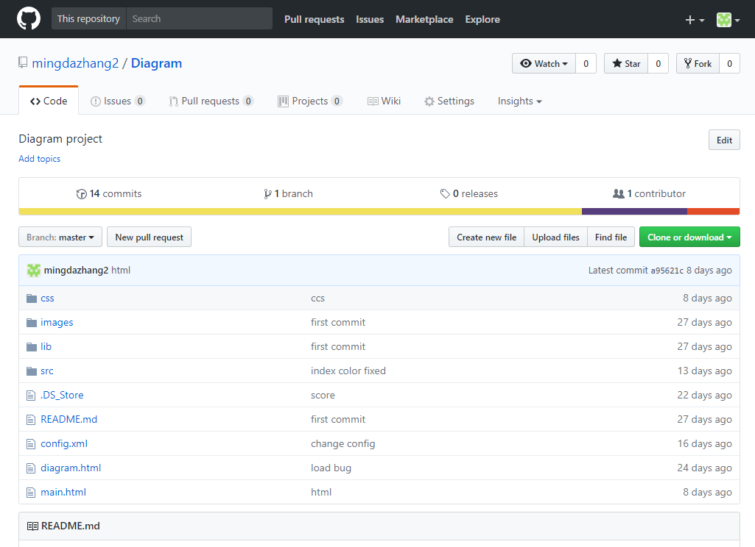

API document for maintenance

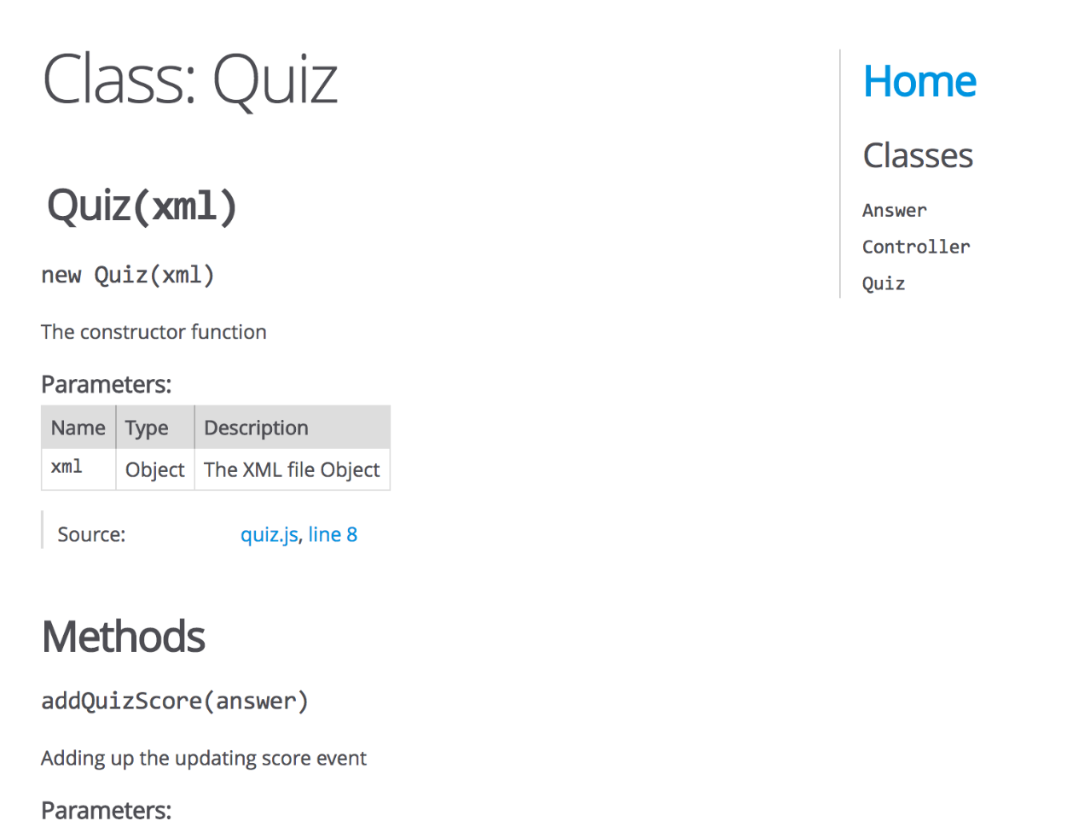

**COURSE MANAGEMENT**

* established - course proposal signed off on 6 Sept 2017
* actively maintained – attend to class every time and do the work follow supervisor’s suggestion.
* extensive
  + I have learnt different areas of knowledge, like risk management, time track
* exceptionally effective
  + my work is always on track
* displaying excellent control
  + make a plan of the course through the whole semester
* initiating communication throughout its execution.

**THE PROJECT**

* completed the project
* to the industry supervisor’s satisfaction
* demonstrating an exceptional grasp of the subject.

**CONTENT OF THE LEVEL 200 AND 300 COURSES**

* correctly identified - all 6 courses are included
* evaluated content – see pages 13-16
* shows material has been applied in a relevant and innovative manner – see recommendation paragraphs on pages 13-16
* perceptive content recommendations

**QUALITY ASSURANCE PROGRAMME see page 19-20**

* created
* maintained
* applied
* comprehensive
* in-depth understanding
* critically analysed
* insightful conclusions

**RISK MANAGEMENT PROGRAMME see page 16-18**

* created
* maintained
* applied
* comprehensive
* in-depth understanding
* critically analysed
* insightful conclusions

**METHODOLOGIES ESSAY/REPORT – see my eassy**

* extensively referenced accepted theory
* industrial practice
* related
* exceptional standard.

**REPORT**

* polished
* imaginative
* clearly and fluent
* insightful
* accurate grammar and spelling.
* very full analysis of performance

**PANEL**

* confident
* skilled communicator
* presented clearly and logically
* responded clearly and logically
* perception in appropriately responding to supervisors’ reports and questions.

**POSTER**

* Imaginatively
* professionally
* displays project’s outcomes
* conveys learning achieved.

# Appendices

**Weekly Report**: See Appendix A

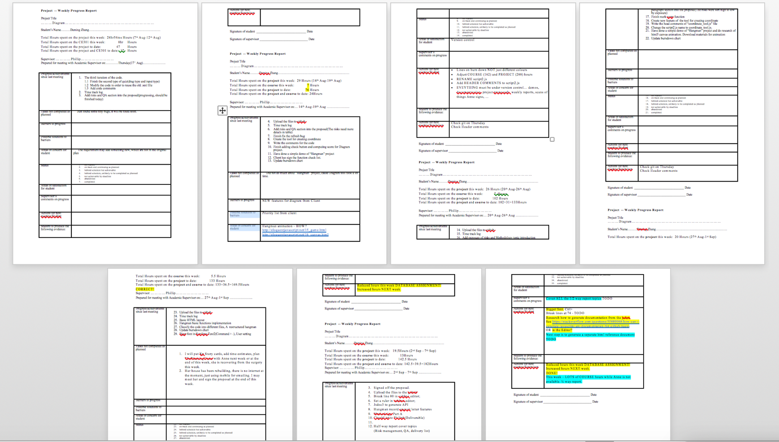

**Weekly Plan**: See folder DailyPlan

All my weekly plan sheet

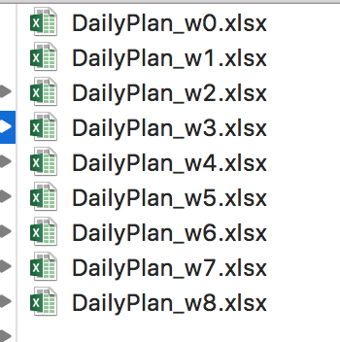

Week 4 plan sheet

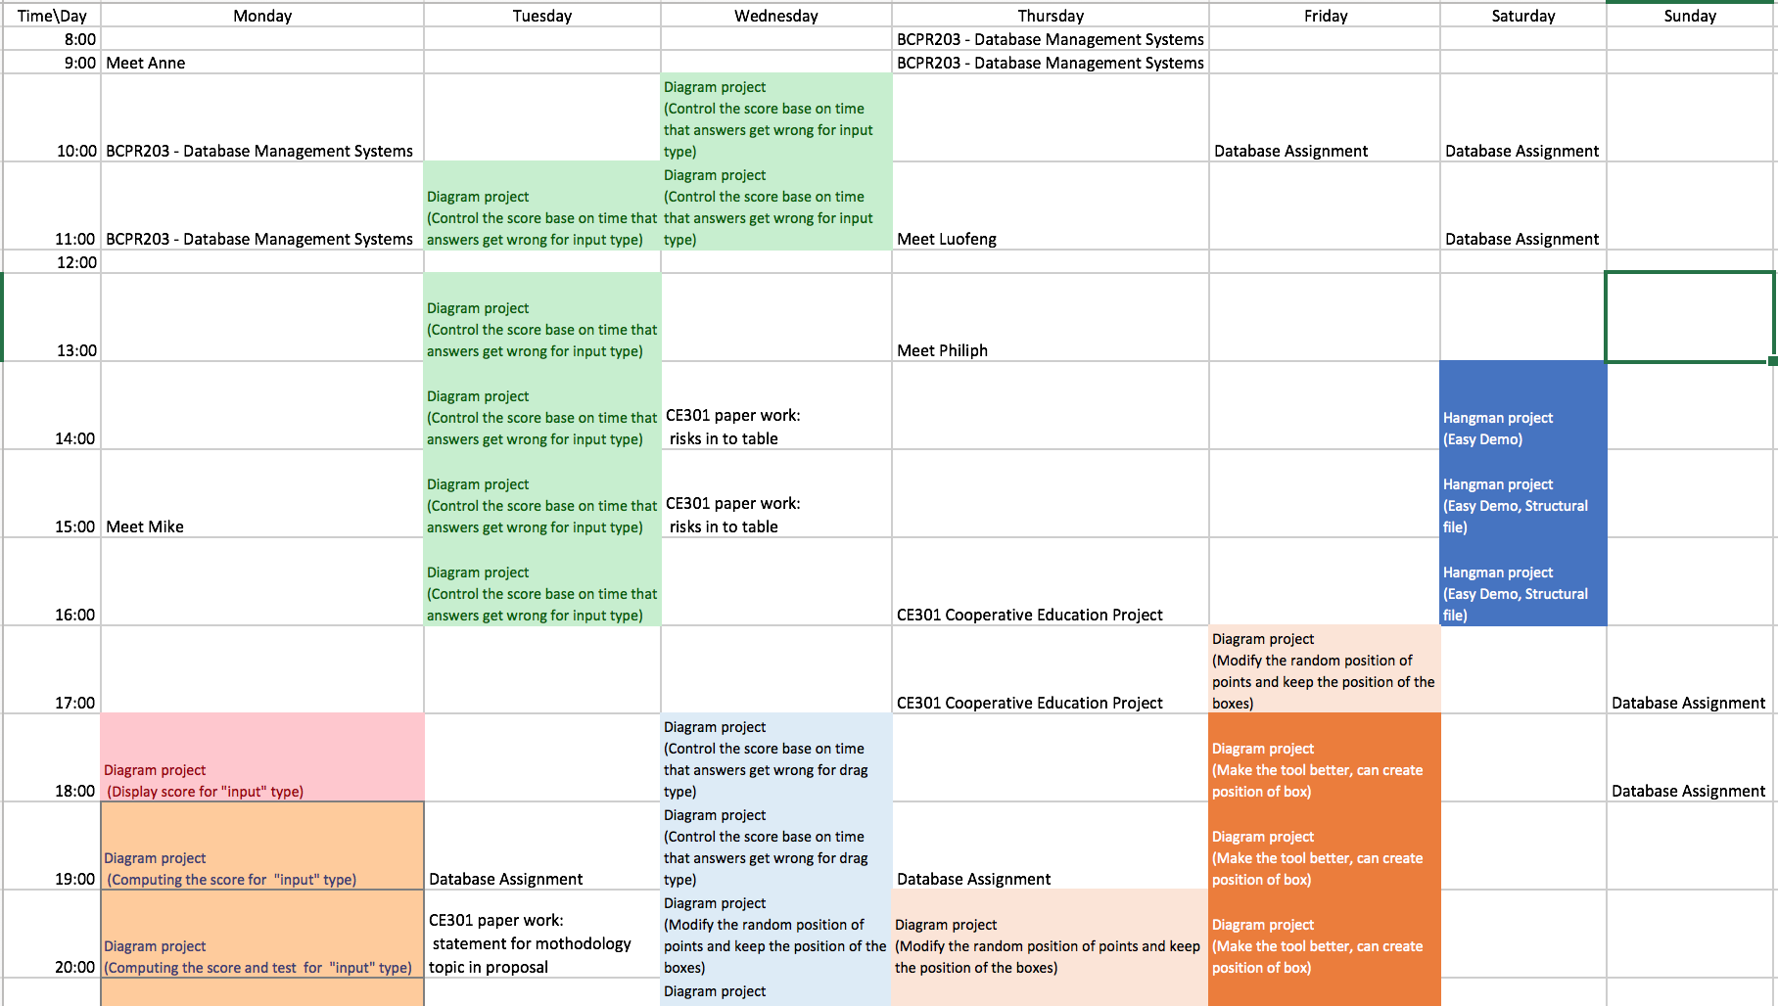

# References